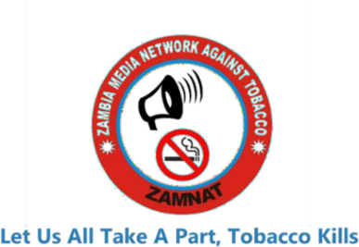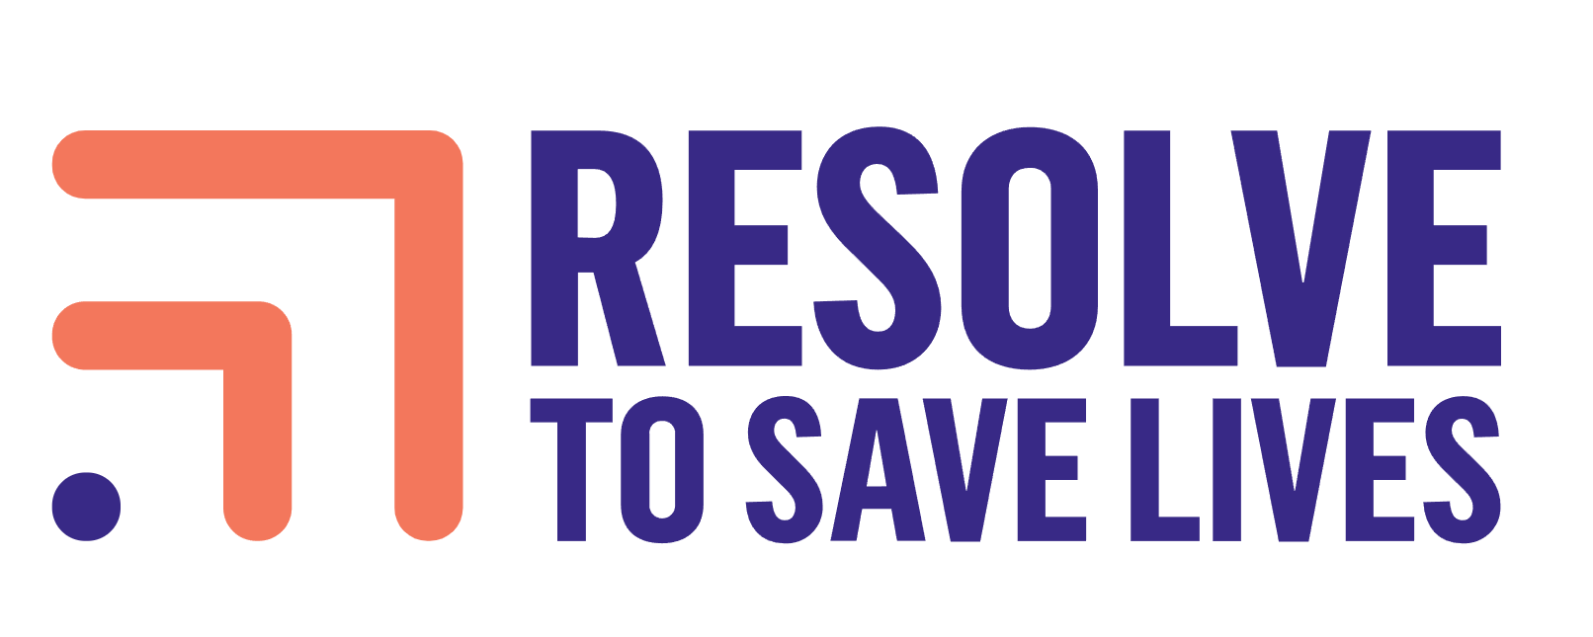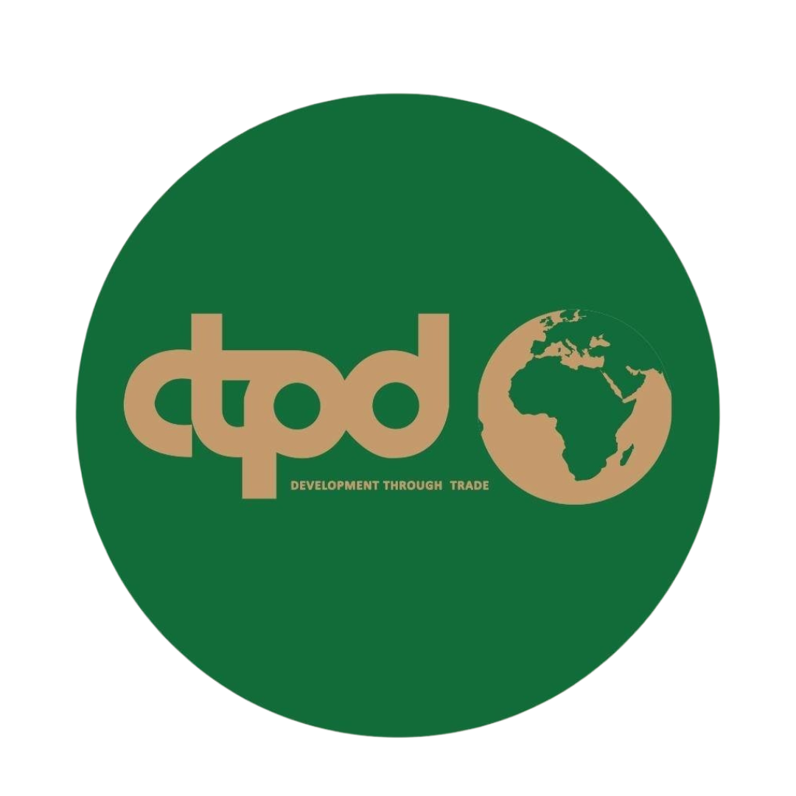

Health Taxes Factsheet

What Are Health Taxes?
Health taxes (sometimes called "sin taxes") are taxes imposed on products that have negative health impacts, including tobacco, alcohol, sugar-sweetened beverages (SSBs), and unhealthy foods. The primary objective is to improve population health through reduced consumption of harmful products, while the secondary objective is to raise government revenue.

The Three Wins of Health Taxes
Health taxes deliver three key benefits:
- Save Lives: Reduce consumption of harmful products, preventing disease and premature deaths
- Reduce Healthcare Costs: Lower burden on health systems by preventing illness
- Generate Revenue: Provide sustainable funding for government priorities, including health systems

Global Evidence and Impact
Countries worldwide have demonstrated success with health taxes:
- Rwanda, South Africa, Ghana: Achieved reductions in smoking and sugar consumption while expanding health care access
- South Africa: Sugary drink tax reduced consumption by 24% among young children, potentially averting thousands of diabetes cases
- Colombia: 20% tax on unhealthy packaged foods generates over $65 million USD monthly
- Mexico: Taxes raised $2.07 billion in 2023 and reduced purchases of taxed foods by 5.1% in the first year
- Hungary: Generated €200 million over four years from unhealthy food taxes

Revenue Potential in Sub-Saharan Africa
A 20% price increase on tobacco, alcohol, and sugary drinks in Sub-Saharan Africa could generate significant revenues, enabling countries to preserve and expand healthcare services by more than doubling public funds available for health care.

Key Implementation Principles
Smart Design Features:
- Specific rather than, or in addition to ad valorem taxes
- Inflation adjustments
- Protection against industry interference
- Physical and digital tax stamps for transparency and increased revenue (30-50% boost)
Success Factors:
- Leadership Commitment: Strong political resolve to withstand industry lobbying
- Civil Society Pressure: Advocacy for equitable health tax policies
- Effective Tax Administration: Evidence-based tax structures for substantial revenues and health gains

Earmarking of Health Tax Revenue
What is Earmarking? Earmarking means setting aside all or a portion of tax revenue for designated health expenditure purposes. At least 80 countries earmark for health, though practices vary from "hard" to "soft" earmarks.
Key Considerations:
- Many countries prefer soft earmarks (aligned with budget processes) to hard earmarks (bypassing budget oversight)
- Earmarking may provide short-term revenue gains but risks creating rigidities and inefficiencies
- Often results in offsetting, where other health funding is reduced
- Most effective when used tto build political support for visible, popular, and high-impact health priorities (e.g., access to primary health care, essential medications, or safe water)
Country Examples:
- Philippines: Earmarked 85% of incremental sin tax revenues for universal health coverage, tripling health resources over 5 years
- Thailand: 2% surcharge on alcohol and tobacco excise taxes funds health promotion foundation
- South Africa: Does not earmark health tax revenue, following broader fiscal policy processes

Special Economic Zones: A Missed Opportunity
Zambia's Special Economic Zones (SEZs) present a significant revenue gap in health tax policy. Products processed within SEZs, including potentially harmful items like tobacco products, sugary beverages, and processed foods, may benefit from tax exemptions or reduced rates. This creates:
- Revenue Loss: Foregone health tax collections on harmful products
- Public Health Gap: Reduced effectiveness of health taxes in curbing consumption
- Unfair Competition: Tax-advantaged harmful products competing with taxed alternatives
- Policy Inconsistency: Undermining health tax objectives while promoting harmful product manufacturing
Addressing this gap could significantly enhance both revenue generation and health outcomes in Zambia.

Recent Zambian Government Health Tax Measures (2025)
The Zambian Government announced significant health tax increases in its 2025 Supplementary Budget to raise approximately ZMW3.9 billion:
Tobacco Products:
- Cigarette excise duty increased from ZMW452 to ZMW750 per mille (66% increase)
Alcoholic Beverages:
- RevoZMWed 40% suspension of excise duty on clear beer, replacing with 50% excise duty
- Increased excise duty on spirits and wine to 80% from 60%
Sugar-Sweetened Beverages:
- Doubled import excise duty rate on non-alcoholic beverages (sugary drinks) to ZMW2.00 per litre from ZMW1.00 per litre
New Additional Taxes:
- Introduced 10% excise duty on betting services (amounts placed on bets)
These measures, effective July 2025, represent substantial increases that align with WHO recommendations for health tax levels and demonstrate Zambia's commitment to using fiscal policy for public health improvement.

Addressing Industry Opposition
Common industry arguments against health taxes include claims about job losses, economic harm, and illicit trade. However, evidence shows:
- Health taxes are generally progressive when medical expenses and working life gains are considered
- Industry often overstates illicit trade estimates compared to independent studies, and illicit trade correlates primarily with effective tax administration, not levels of taxation
- Health taxes can be implemented without significant economic disruption when properly designed

Advocacy priorities for Zambia
- Strengthen Tax Design: Implement specific taxes with regular inflation adjustments
- Address SEZ Exemptions: Review and reform tax treatment of harmful products in special economic zones
- Consider Soft Earmarking: Earmark health tax revenues, at least temporarily, to build political support and ensure health system investments
- Expand Coverage: Consider taxes on unhealthy foods with front-of-package warning labels in the future
- Build Coalitions: Engage civil society and health advocates to counter industry lobbying
- Monitor and Evaluate: Track consumption patterns, revenue generation, and health outcomes

References
- Africa CDC. Health Financing Report. Champions health taxes on alcohol, tobacco, and sugary drinks to generate sustainable health revenue.
- Blecher, E. 2020. South Africa health tax implementation and revenue generation analysis.
- Bloomberg, M., Summers, L., et al. 2020. "Health Taxes to Save Lives: Employing effective excise taxes on tobacco, alcohol and sugary beverages." Bloomberg-Summers Task Force on Fiscal Policy for Health.
- Cashin, C., Sparkes, S., and Bloom, D. 2017. "Earmarking for Health: From Theory to Practice." Geneva: World Health Organization.
- DIAN: Dirección de Impuestos y Aduanas Nacionales. 2025. Annual Tax Revenue Statistics for Colombia's unhealthy food taxes.
- Kruger, H. Salome et al. 2025. "Decreased frequency of sugar-sweetened beverages intake among young children following the implementation of the health promotion levy in South Africa." Public Health Nutrition 28(1).
- Ministry of Finance and National Planning, Republic of Zambia. 2025. Supplementary Estimates No. 1 of 2025. July 3, 2025.
- Ozer, C., Bloom, D., et al. 2020. "Health Earmarks and Health Taxes: What Do We Know?" World Bank Health, Nutrition and Population Knowledge Brief.
- Resolve to Save Lives. 2024. "Healthy Revenue: Four Taxes, Three Wins" and "Unlocking Health and Prosperity in Zambia Through Health Taxes."
- Task Force on Fiscal Policy for Health. 2024. "Health Taxes: A Compelling Policy for the Crises of Today."
- World Health Organization. 2023. WHO Report on the Global Tobacco Epidemic.
- World Health Organization Regional Office for Europe. 2016. Assessment of the Impact of a Public Health Product Tax: Final report on Hungarian implementation.

This factsheet is designed for workshop participants examining health tax policy implementation in Zambia. For additional information on specific tax design and implementation strategies, consult the referenced sources above.

